Math 1309 – Quiz 9 Spring 2012
Name:

Show all your work, unsupported answers will receive no credit. Use correct mathematical notation at all times, points will be deducted for incorrect notation. Box your answers.

- Find each of the indicated definite integrals. Do not leave complex fractions in your answers.
a) 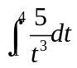 b) 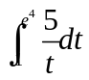

c) 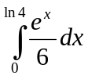 d) 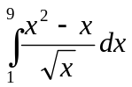

2. The projected rate of increase in enrollment in a new college is estimated by the expression
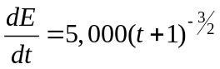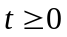
where E(t)is the projected enrollment in t years. If enrollment is 2,000 now (t=0)
a) Find a formula for E(t)
b) Find the projected enrollment 8 years from now

3. Approximate the area under the graph of the function 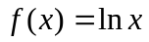between x = 1 and x = 3. Use a regular partition with 8 subintervals and the left end of each subinterval. Draw the graph of the function and shade the area that you are calculating.

